RETAIL ANALYTICS PROJECT REPORT

1. Introduction
Retail analytics is the process of analyzing sales data to understand customer behavior, product performance, and business trends. In this project, retail transaction data is analyzed using SQL to generate meaningful insights that help improve business decisions.

2. Objectives
The main objectives of this project are:
- To analyze retail sales data
- To calculate total revenue and total quantity sold
- To identify top-selling products
- To analyze customer purchasing behavior
- To study sales across different countries and time periods

3. Tools Used
- MySQL (Database Management System)
- MySQL Workbench (SQL execution and analysis tool)
- CSV Dataset (Retail data source)
- Microsoft Excel (for data visualization)
- Microsoft Word (Report preparation)

4. Dataset Description
The dataset contains retail transaction details with the following attributes:
- Invoice
- StockCode
- Description
- Quantity
- InvoiceDate
- Price
- Customer ID
- Country
Each record represents a transaction of a product purchased by a customer.

5. Data Cleaning
Before performing analysis, the dataset was cleaned to ensure accuracy:
Checked for NULL values in the Description column
Verified that no missing or invalid data existed
Handled column names with spaces (e.g., Customer ID)
Ensured consistency in data types

6. Data Analysis and SQL Queries

Total Quantity Sold
SELECT SUM(Quantity) AS Total_Quantity FROM retail;

Total Revenue
SELECT SUM(Quantity * Price) AS Total_Revenue FROM retail;

Top Selling Products
SELECT Description, SUM(Quantity) AS Total_Sold
FROM retail
GROUP BY Description
ORDER BY Total_Sold DESC
LIMIT 10;

Total Number of Orders
SELECT COUNT(DISTINCT Invoice) AS Total_Orders FROM retail;

Country-wise Sales
SELECT Country, SUM(Quantity * Price) AS Revenue
FROM retail
GROUP BY Country
ORDER BY Revenue DESC;

Monthly Sales Analysis
SELECT DATE_FORMAT(InvoiceDate, '%Y-%m') AS Month,
SUM(Quantity * Price) AS Revenue
FROM retail
GROUP BY Month
ORDER BY Month;

Top Customers
SELECT `Customer ID`, SUM(Quantity * Price) AS Total_Spent
FROM retail
GROUP BY `Customer ID`
ORDER BY Total_Spent DESC
LIMIT 10;

7. Data Visualization Using Excel
After performing data analysis using SQL, the results were further visualized using Microsoft Excel to gain better insights.

Tools Used
- Microsoft Excel / WPS Office
- Pivot Tables
- Charts (Bar Chart, Line Chart)

Country-wise Revenue and Quantity Analysis
A pivot table was created to analyze revenue and quantity for each country. A bar chart was used to compare performance across different countries.
Insight:
- The United Kingdom generated the highest revenue
- Other countries contributed comparatively less

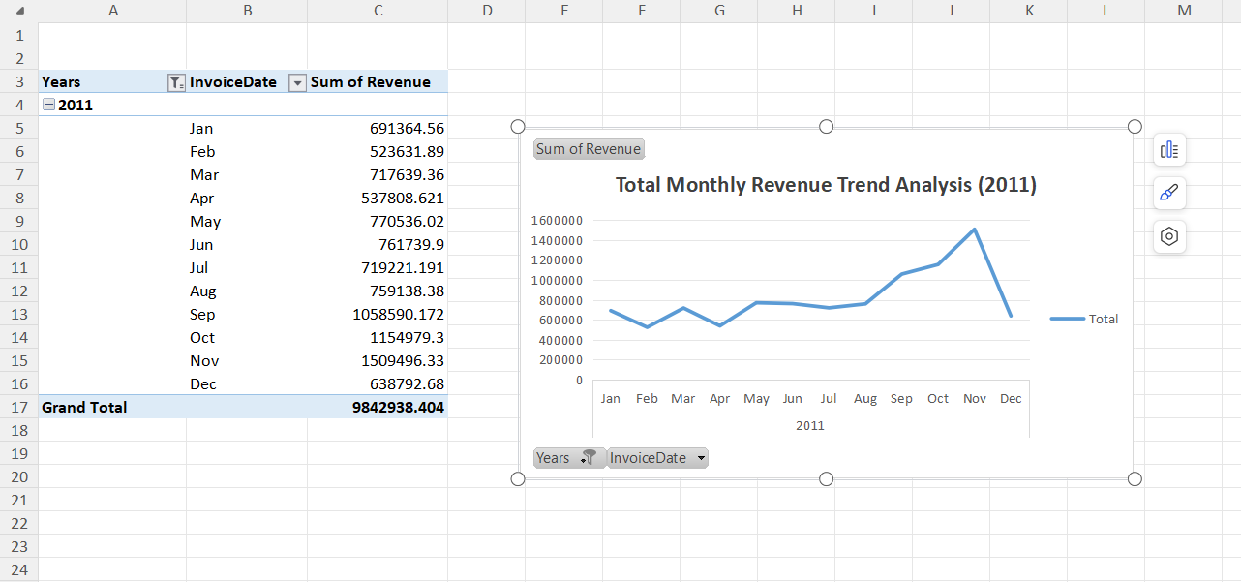

Monthly Sales Trend Analysis
A line chart was created to analyze monthly revenue trends.
Insight:
- Sales showed variation across months
- Peak sales observed in certain months (e.g., November)

Customer Analysis
A pivot table was used to identify top customers based on revenue.
Insight: A few customers contributed significantly to total revenue

Quantity Distribution by Country
A bar chart was used to analyze product quantity distribution across countries.
Insight:Some countries had higher product demand compared to others

Benefits of Visualization
- Helps in easy understanding of data
- Improves decision-making
- Makes analysis more interactive and clear

8. Conclusion
This project successfully demonstrates the use of SQL for retail data analysis. By performing queries such as aggregation and grouping, meaningful insights were extracted from the dataset. These insights can help businesses make informed decisions, improve sales strategies, and enhance customer satisfaction.In addition to SQL analysis, Excel visualization was used to present insights in a graphical format, making the results easier to understand

9. Future Scope
- Visualization using Python (Matplotlib / Seaborn)
- Dashboard creation using Power BI or Tableau
- Advanced analytics using machine learning

